Reading Motion Graphs #2

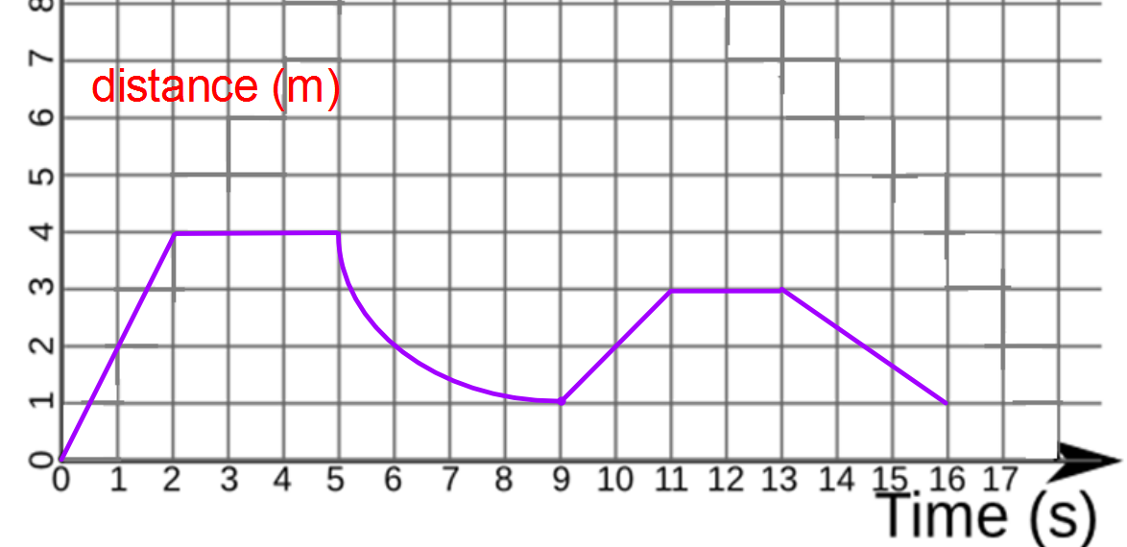
1. In this graph, when is the object moving away from its starting point?

2. In this graph, when is the object moving closer to its starting point?

3. In this graph, when is the object at rest (not moving)?

4. In this graph, when is the object moving with constant speed?

5. What is the average speed of the object for the entire trip?

6. What is the average speed of the object for the first 10s?

7. Did the object return back to where it started at the end of the trip? What is the object’s displacement?

